Students Name
Boiling Point of Water
Purpose
The purpose of this lab is to determine the boiling point of water.
Hypothesis
If the pressure in the classroom is close to 1 atmosphere, then the boiling point of water should be approximately 100 degrees Celsius.
Background Information
Kinetic theory states that all molecules in matter are in constant motion (Kane and Sternheim, 1984). As these molecules absorb more energy they have a higher amount of random movement. As energy is absorbed in the form of heat the average kinetic energy (temperature) of the molecules will increase except during a phase change. The absorbed energy used in the phase change breaks the attractive forces between the molecules, thus transformation occurs in the orientation of the molecules. An example of a phase change would be the boiling point of water which is a change from a liquid to a gas. This can be observed by using a temperature versus time line graph when the slope becomes zero (plateau) The boiling point of water is expected to be 100.00 oC (Merck, 1976).
Materials
- 500 ml beaker
- distilled water
- thermometer
- hot plate
- Word Processing Software
Procedure
- Fill beaker with approximately 300 ml of distilled water.
- Place the beaker on the hotplate.
- Place the thermometer in the beaker and record the initial temperature.
- Turn the hotplate to high.
- Record temperature every two minutes until six minutes after boiling begins.
- Turn hotplate off and allow materials to cool for at least 10 minutes before the equipment is dismantled.
Data
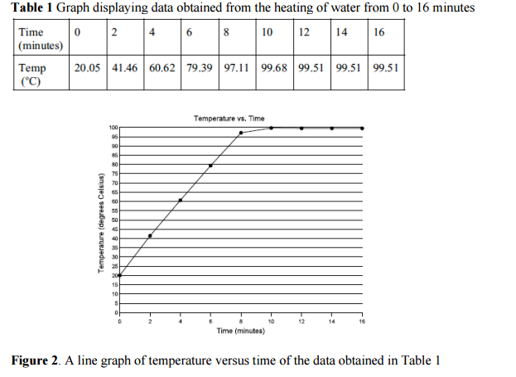
Conclusion:
The purpose of the lab was to determine the boiling point of water. If the pressure in the classroom is close to 1 atmosphere, then the boiling point of water should be approximately 100 degrees Celsius. The hypothesis was accepted.
It was determined from the data plotted in the temperature versus time graph (Figure 1) that the boiling point of water is 99.51 degrees Celsius. This concurs very closely with the stated hypothesis; therefore the experiment was deemed a success.
Possible sources of error could have involved impurities in the water and human error in reading the thermometer. Impurities in the water may have been previous chemicals from dirty glassware. Improvements would include more accurate thermometers, clean equipment and proper reading of the thermometer.
Works Cited
Kane, Joseph W. and Morton M. Sternheim. Physics. New York: John Wiley & Sons, 1984 ed. Merck, Josef. Merck Index of Chemical Constants. New York: Benjamin/Cummings Publishing Company Inc. 1976.

