Name_________________________ Unit 5 Oceanography
Vocabulary (Ch. 14)
Define on a separate sheet of paper

- Oceanography
- Bathymetry
- Sonar
- Submersible
- Continental margin
- Continental shelf
- Mid ocean ridge
- Seafloor spreading

Websites:
- http://www.reefnews.com/reefnews/infopage/oceans/oceans.html
- http://www.glencoe.com/sites/common_assets/science/virtual_labs/ES18/ES18.swf
- http://www.education.noaa.gov/Ocean_and_Coasts/Ocean_Floor_Features.html

Questions:
- _______________ Ocean is the largest ocean. It covers _______ % of the Earth.
- This is the 5th ocean, sometimes not recognized by textbooks. __________________________________
- This ocean is so cold it is almost completely frozen during the winter. ___________________________
4. What are some examples of Benthos? _____________________________________________________
5. What makes Nekton swimming abilities different from plankton and benthos? _____________________
6. Plankton rely on what for movement? _____________________________________________________
7. What is the deepest part of the Pacific Ocean? _______________________________________________
What about the Atlantic Ocean? __________________________________________________________
8. Seawater contains about ________ % salt.
9. Label.
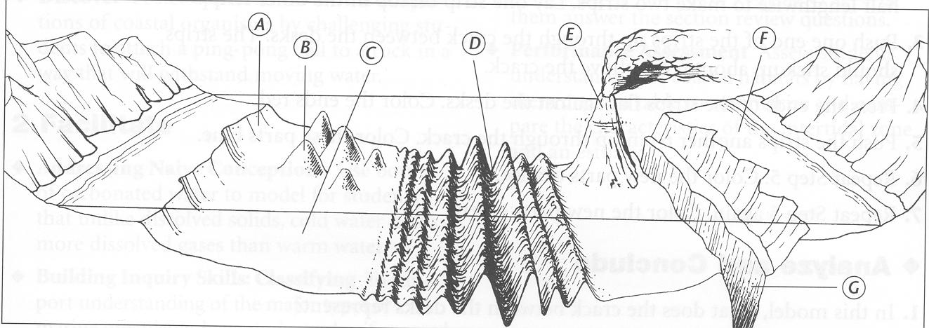
A. __________________________ B. _________________________
  - __________________________ D. _________________________
E. ___________________________ F. __________________________
G. __________________________

Vocabulary (Ch. 15)
Define on a separate sheet of paper

- Salinity
- Thermocline
- Density
- Mixed zone
- Plankton
- Phytoplankton
- Zooplankton
- Nekton
- Benthos
- Photic zone
- Intertidal zone
- Neritic zone
- Oceanic zone
- Pelagic zone
- Benthic zone
- Abyssal zone

Hydrosphere Webquest
http://hydrowebquest.weebly.com/
Click get started and read introduction. Then click start the webquest to begin.
Start with zone 1- Intertidal Zone http://noaacontent.nroc.org/lesson10/l10la2.html

1. What is the intertidal zone?

2. Why is the intertidal zone so harsh?

3. What are the four subdivisions of the intertidal zone?

4. Complete the chart about each zone.
Name of the subdivision | Location of Subdivision | Animals found in subdivision | Adaptations animals have that help them to live in subdivision

Proceed to the Neritic Zone https://en.wikipedia.org/wiki/Neritic_zone (link is broken on site so type it in or go to live link in worksheet on site)
1. How deep does the Neritic Zone extend?

2. What types of autotrophic life live in this zone (give three examples).

3. Why is kelp important to the Neritic Zone ecosystems?

4. Why is the kelp canopy used by organisms as a nursery?

5. How do scientist use the kelp forest to monitor the ecosystem where kelp forest are found?

Benthic Zone 1 and 2 http://www.nhptv.org/natureworks/nwep6j.htm and http://www.newworldencyclopedia.org/entry/Benthic_zone
1. What animals are considered benthos?

2. What are some of the characteristics of this ecosystem that makes it unique?

3. How is life in the benthic zone (the benthos) organized?

4. The Abyssal is also part of the Bentic Zone. Where can it be found?

5. What are the specific characteristics of the Abyssal? (Give at least three.)

Deep Ocean Exploration http://ocean.si.edu/deep-sea

1. At what depth does that water get so cold that it borders on freezing?

2. (After watching the video) Name five unique animals found in the deep ocean by ROV’s.

3. (Using the link “sophisticated technologies”) What is the difference between an ROV, an AUV, and a Hybrid Vehicle?

4. (Using the link “sophisticated technologies”) The Nereus is the deepest diving Hybrid Vehicle. What is the deepest it has reached and where did it visit on this dive?

5. (Using the link “underwater vehicles”) Which of the submersibles is your favorite? Why and what did it discover or do that is unique for the other submersibles?

Vocabulary (Ch. 16)
Define on a separate sheet of paper

- Ocean current
- Surface current
- Gyre
- Coriolis effect
- Upwelling
- Density current
- Wave height
- Wavelength
- Wave period
- Fetch
- Tide
- Tidal range
- Spring tide
- Neap tide

Ocean Currents Webquest
Websites:
- http://www.montereyinstitute.org/noaa/lesson08.html
- http://www.onr.navy.mil/Focus/ocean/motion/waves1.htm
- http://home.hiwaay.net/~krcool/Astro/moon/moontides/
Questions:
- What are the 3 different types of breaker waves.
  - ____________________________
  - ____________________________
  - ____________________________
- True or False – Tsunamis are easy to spot in the open ocean.
- Tsunamis can reach heights of up to __________ ft.
- What are 2 ocean current systems?
  - __________________________
  - __________________________
    - Which is the largest? _____________________
5. Describe and explain the motion that energy moves through a wave. ____________________
________________________________________________________________________________________________________________________________________________________________________
6. What are three events that can happen in the ocean that causes tsunamis?
  - ____________________________
  - ____________________________
  - ____________________________
7. ____________________ is the largest contributor to surface currents?
8. The Coriolis deflection is to the ____________ in the northern hemisphere and to the ____________ in the southern hemisphere.
9. How did the iceberg that hit the Titanic end up in the Atlantic? _________________________ ____________________________________________________________________________
10. Label the parts of a Wave:

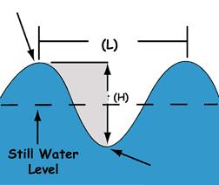

Crest Wavelength Trough Wave height

