Name_____________________ Unit 6 Meteorology
Part 1.Air Masses
- Go to the website: http://okfirst.mesonet.org/train/meteorology/AirMasses.html
- What is an air mass?

b. The boundary between two different air masses is called a __________________________________.

- Explain the difference between a “continental(c) ” air mass, and a “maritime(m)” air mass.

- Explain the difference between a “polar(P)” air mass and a “tropical(T)” air mass.

e. Using the map on the webpage, label each of the bubbles below.
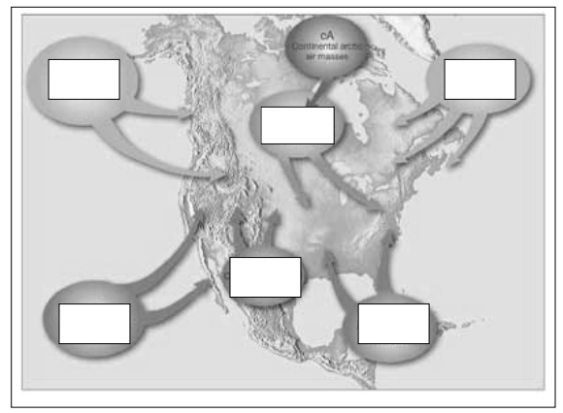
f. Then, describe an air mass by its Moisture content and Temperature, so each air mass has two letters. Using the chart at http://www.islandnet.com/~see/weather/elements/airmasses.htm, name each air mass and describe it by moisture content and temperature.
cP = _______________________________________________________________
cT = _______________________________________________________________
mP = ______________________________________________________________
mT = ______________________________________________________________

g. Three air masses affect North Carolina’s weather the most. Name their air mass symbols and tell me where they come from.

Part 2. Global Winds - Go to http://ww2010.atmos.uiuc.edu/(Gh)/wwhlpr/global_winds.rxml

- What are Global Winds? ___________________________________________________________________
- Label parts B through L in the diagram below
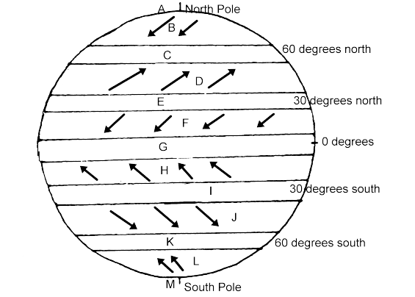

3. Go to the website: http://www.weatherquestions.com/What_causes_high_pressure.htm to find out what causes a high pressure air mass.
a. What causes an air mass to have a high pressure?

4. The website http://www.weatherquestions.com/What_causes_low_pressure.htm will help you answer the following question:
- What causes an air mass to have a low pressure?

5. Look at this picture: http://www.physicalgeography.net/fundamentals/images/thermal2.GIF.
a. Does air move from high pressure to low, or low to high?

Part 3. Coriolis Effect
6. The Coriolis Effect affects Earth’s winds. Read the information at this website to find out about the Coriolis
Effect: http://ww2010.atmos.uiuc.edu/(Gh)/guides/mtr/fw/crls.rxml. The video at the bottom will give you a visual of the Coriolis Effect.
- In the video, why does the ball not roll straight across the merry-go-round?

- How is the Earth similar to the merry-go-round? (Look at the figure)

- What happens to objects in the Northern Hemisphere as a result of the Coriolis Effect?

d. Wind is an object that is affected by the Coriolis Effect. What happens to winds in the Northern Hemisphere as a results of the Coriolis Effect?

e. Click on the “Pressure Gradient” link on the column at the left. What is the direction of the net force between two pressure systems? From pressure to pressure.

f. Click on the “High” link. What is a High Pressure Center and what does it mean?

Wind is an object that is affected by the Coriolis Effect. View the following animations on Coriolis Effect.

http://www.classzone.com/books/earth_science/terc/content/visualizations/es1904/es1904page01.cfm

http://www.classzone.com/books/earth_science/terc/content/visualizations/es1905/es1905page01.cfm

7. What happens to winds in the Northern Hemisphere as a result of the Coriolis Effect? ____________________________________________________________________________________

8. Go to http://www.srh.noaa.gov/jetstream/synoptic/wind.htm to read about Origin of Wind.
a. A ________________ _____________ measures the wind direction and an _______________________ measures the wind speed.
b. When rising air _______________, it can lead to clouds and precipitation because cool air can hold less water vapor.
c. Sinking air _____________ causing evaporation of clouds, thus fair weather.
d. Isobars means _______________ __________. Isobars, or lines of equal pressure, may be packed together indicating __________________ pressure gradient.
e. Pressure gradient is the difference in pressure between high and low pressure areas. The strongest winds are in areas where the pressure gradient is the _____________________________.

9. What three forces cause the wind to move?
a. ____________________
b. ____________________
c. _________________

Part 3. Pressure Centers and Weather
10. Go to the website listed here: http://ww2010.atmos.uiuc.edu/(Gh)/wx/surface.rxml. Then, find the picture that says “Sea Level Pressure with IR satellite”. Click on this figure to bring up a new window. Click on the button that says “Animate”. Choose “96 frames”. Answer the following questions:
`a. This map shows you isobars and cloud cover. What is an isobar?

- Look at the map and find Wilmington. What isobar is near us?

- Press “Play” on the window, and watch where the clouds travel. Do the clouds tend to be near High pressure centers (H) or Low pressure centers?

12. This website will help explain why High pressure centers usually mean good weather, and Low pressure centers usually mean bad weather: http://www.usatoday.com/weather/tg/whighlow/whighlow.htm. Go here and read to discover why this is true, and then answer the following questions:
a. Air descends (comes down) at High pressure areas. Why does descending air not allow for clouds to form?

b. Air ascends (goes up) at Low pressure areas. Why does ascending air allow for clouds to form?

- Use diagram to determine the direction of wind motion. What is the direction around a High-pressure system?

- What is the direction around a Low-pressure system?

13. For the following link http://www.tulane.edu/~sanelson/geol204/oceanatmos.htm scroll down to Wind Systems to help you further understand high pressure centers and low pressure centers in the Northern Hemisphere.
Since winds blow from areas of high pressure to areas of low pressure, winds spiral outward away from the high pressure. Because of the Coriolis Effect, winds will be deflected toward the right in the northern hemisphere and create a general ________________ ____________ around the high pressure center. Winds circulating around a high pressure center are called _____________ __________. Air that is less dense ascends and creates a low-pressure center. Again, winds blow from areas of high pressure to areas of low pressure, but the winds are deflected toward the right in the Northern Hemisphere and instead circulate around in a _________________ _____________ fashion. These are known as ______________ winds.

Part 4. Frontal Boundaries
This website will help you to understand a frontal boundary. Read the Introduction at the top and answer the following questions. http://www.phschool.com/atschool/phsciexp/active_art/weather_fronts/
What is a weather front?
14. Play the Cold front animation and read the information above to answer the questions below.
a. Which air mass is doing the pushing?

- What forms when the warm air gets pushed ”up” by the cold air?

- What kind of clouds form at the frontal boundary?

- What weather is associated with this cloud type?

15. Play the Warm Front animation and answer the questions below.
a. Which air mass is doing the pushing?
b. Dry warm air forms _______________ _________________. Warm air that is humid brings __________________________________________________________.
c. Warm fronts move more ________________ than cold fronts.
16. Below you will see on the weather map the symbol for a Cold Front is a Blue line with Triangles and a Warm Front is a Red line with half-circles. Label the diagram to show where the cool, dry (cP) air mass and the warm, moist (mT) air mass is in the picture.
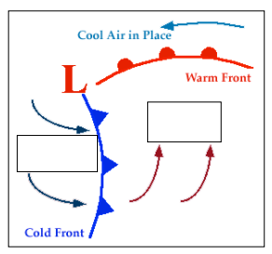
- Along which front Along which frontal boundary will thunderstorms develop?

- Along which frontal boundary will all-day rain occur?

- Look at the wind arrows on the diagram, do they match the direction of motion you determined in questions 10 d? What direction is that?

17. What happens at a Stationary Front? Find out the weather map symbol for a Stationary Front and draw below. http://nsidc.org/arcticmet/factors/pressure.html
18. Click on this website to see the Current Weather Map. http://www.weather.com/maps/maptype/currentweatherusnational/index_large.html
a. Where is a Cold Front occurring?

b. Where is a Warm Front occurring?

- What type of air mass are we currently in?

Part 6. Severe Weather / Changing Weather
16. Visit http://www.tramline.com/tours/sci/hurricane/_tourlaunch1.htm to read about hurricanes.
Click twice on the arrow in the lower right-hand box.
Hurricanes are tropical cyclones with winds that exceed ____ knots (___mi/hr) and blow counterclockwise in the Northern hemisphere, (clockwise in the Southern hemisphere). How does this relate to what you learned about low pressure areas? _________________________. Hurricanes are born over the_________________________________, where humid air and converging winds fuel the conditions. Hurricane season is usually (when) __________________________________________________________. The primary components of a hurricane include:
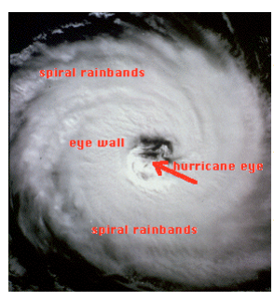
____ _______: A region 20-50 km in diameter found at the center where skies are often clear, winds are light, and the storm's lowest pressure readings are obtained.
_____ ________: A ring of cumulonimbus clouds that swirl around the eye. The heaviest precipitation and strongest winds are found here.
_______ ___________: Bands of heavy convective showers that spiral inward toward the storm's center.
17. El Nino - http://ww2010.atmos.uiuc.edu/(Gh)/guides/mtr/eln/elyr.rxml causes a build-up of ___________ ___________ ____________in the Eastern Pacific.
a. Limits the upwelling process = ______________________________
b. Warmer waters shift eastward = _____________________________________
c. The flooding in coastal deserts of S. America = _________________________________________________
d. Leaving a dry condition in ________________ and ___________________________.
18. La Nina forecasts: http://www.noaanews.noaa.gov/stories2011/20110908_lanina.html La Niña is a naturally occurring climate phenomenon located over the tropical Pacific Ocean and results from interactions between the ocean surface and the atmosphere. During La Niña, ____________________________ Pacific Ocean temperatures influence global weather patterns.
a. La Nina means continued ______________________ for Texas, Oklahoma and New Mexico.
b. Calls for an ____________________ hurricane season.
c. In 2011 La Nina contributed to record winter snowfall, __________ _______________ and __________ across the United States, as well as other extreme weather events throughout the world, such as ___________________ in ________________ and an extremely dry equatorial _________________ _____________

